Activity 11-1 Finding Vulnerabilities with Default SSIDs
Step 1
I started my computer and logged into Windows.
After that, I opened a web browser and navigated to https://nvd.nist.gov.
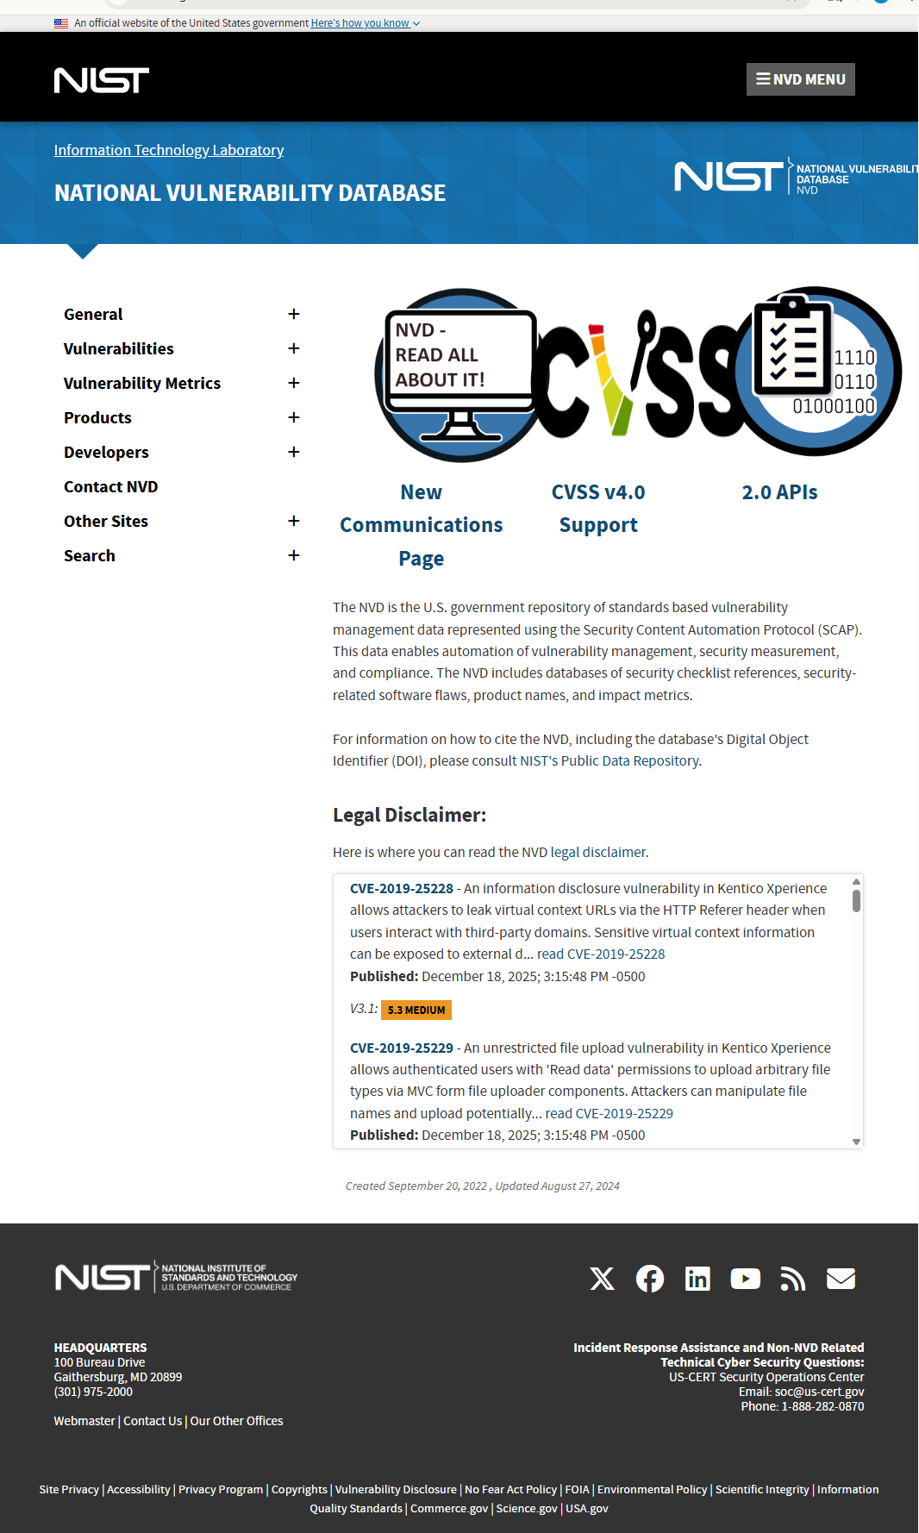
The National Vulnerability Database (NVD) homepage loaded successfully, confirming access to the vulnerability database.
Step 2
From the left-side navigation pane on the NVD homepage, I clicked on Search.
This redirected me to the NVD Vulnerability Search page.
Step 3
On the Search page, I selected Vulnerabilities – CVE.
This opened the Search Vulnerability Database page, where CVE records can be searched and reviewed.

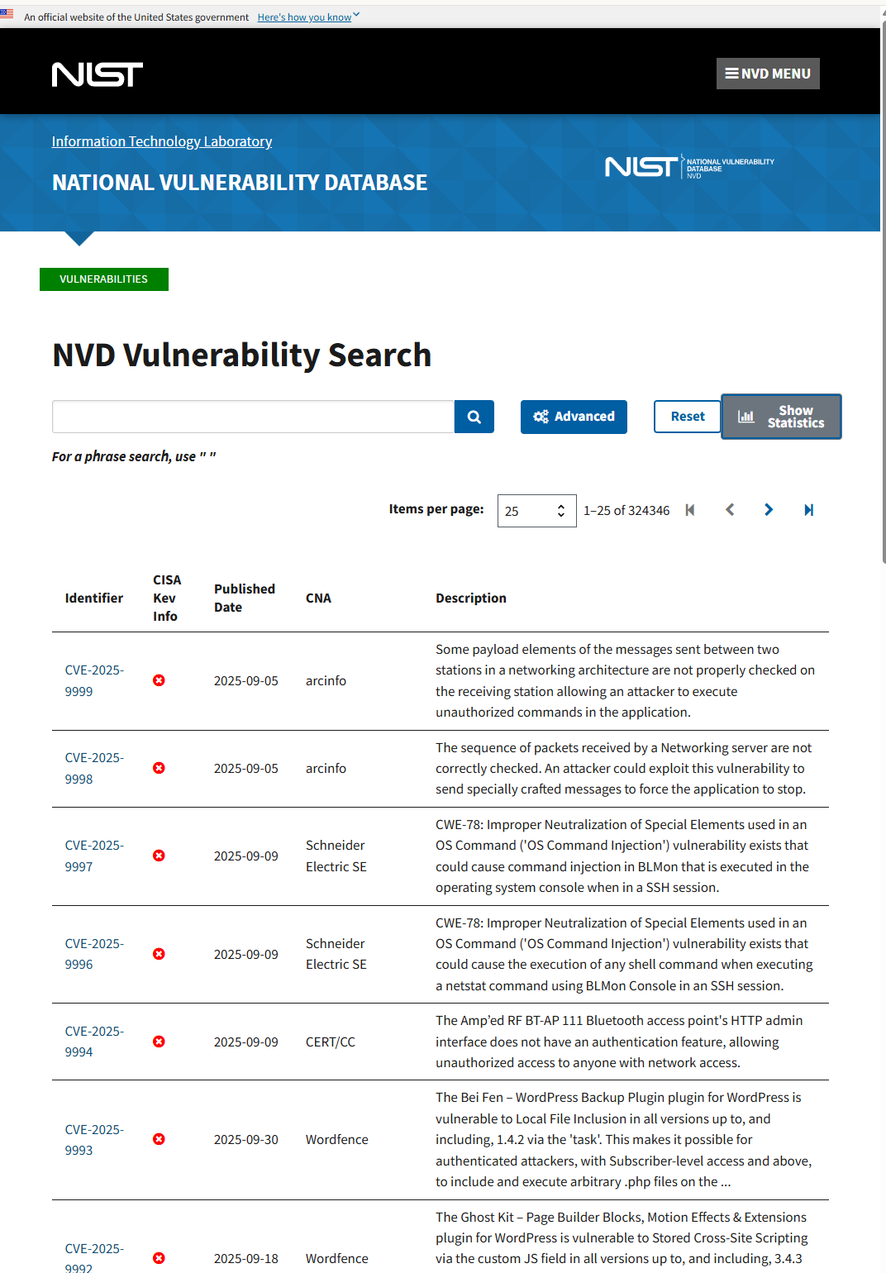
Step 4
On the NVD Vulnerability Search page, I typed dlink wireless in the Keyword Search text box and clicked the Search button.
The search returned no results found, which means there are currently no CVE entries that exactly match the keyword dlink wireless using the default search settings.
This confirms that the search was performed correctly. To review vulnerabilities with high CVSS scores, the search criteria would need to be adjusted for example, using D-Link or a specific router model.
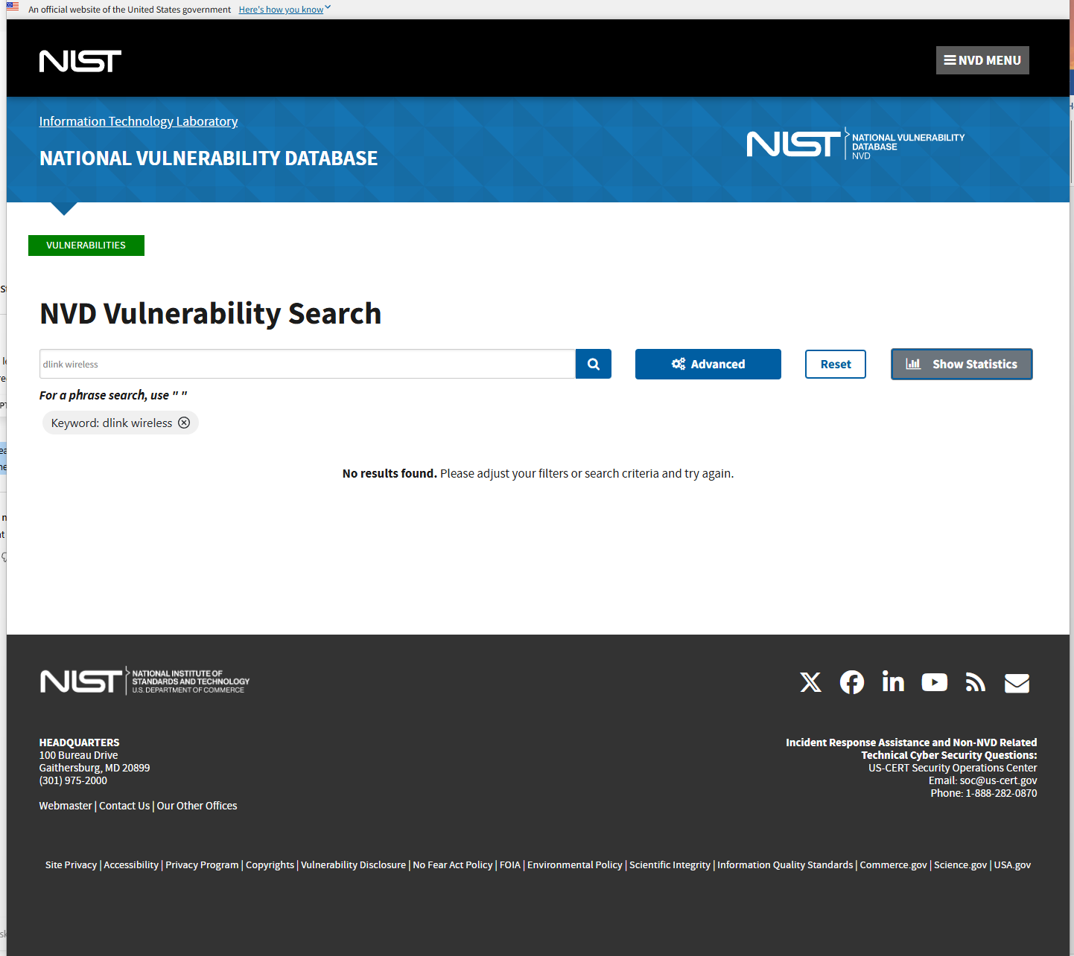

Step 5
After adjusting the search and opening a listed CVE, I clicked on the CVE ID link to view the detailed vulnerability page.
I read the vulnerability summary, which explains how the flaw works and what impact it has.
For the critical vulnerabilities reviewed, the descriptions showed issues such as:
- improper input validation
- command injection
- unauthenticated access or denial of service
Exploit or attack demonstration:
Yes, for some critical vulnerabilities, references and technical details are available, including proof-of-concept information or links to security advisories. These can be used to understand how an attack could be carried out.
Step 6
Yes, the router uses a typical default SSID.
Based on the router make and model reviewed, D-Link wireless routers commonly use default SSIDs such as DLink, D-Link, or DLink-XXXX, where XXXX represents part of the device’s MAC address.
This information was found by searching the router model online along with the term default SSID. Using a default SSID makes it easier for attackers to identify the router brand and look up known vulnerabilities for that specific device.
Step 7
For a client using the selected router, I would recommend changing the default settings to improve security. This includes changing the default SSID, updating the router firmware, and changing the default administrator username and password.
I would also suggest disabling WPS and remote management if they are not needed, and using WPA2-AES or WPA3 encryption. These steps help reduce the risk of attacks and better protect the wireless network.

Step 8
I left the web browser open for the next activity.
Activity 11-2: Visiting the IEEE 802.11 Website
Step 1
I started a web browser and navigated to
http://www.ieee802.org/11/Reports/tgay_update.htm
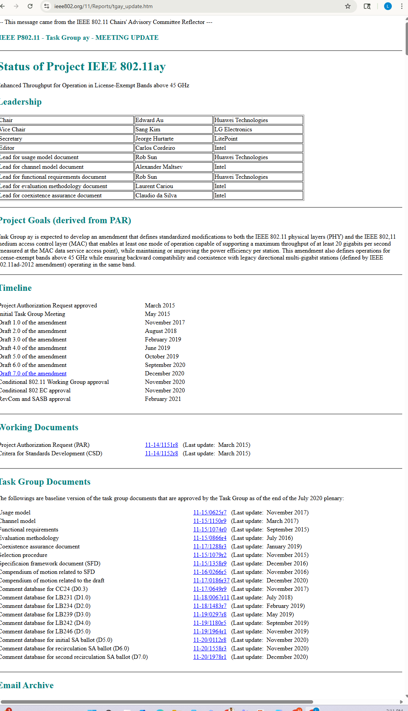
The IEEE 802.11ay project information page opened successfully.
Step 2
I reviewed the project goals of the IEEE 802.11ay specification. The goal of IEEE 802.11ay is to enhance the physical (PHY) and MAC layers to support at least 20 Gbps throughput, operate in license-exempt frequency bands above 45 GHz, improve power efficiency, and maintain backward compatibility and coexistence with existing 802.11ad devices.
Step 3
The theoretical throughput of IEEE 802.11ay is at least 20 Gbps. According to Table 11-2, the throughput of commonly used protocols is:
- 802.11a: 54 Mbps
- 802.11b: 11 Mbps
- 802.11g: 54 Mbps
- 802.11n: up to 600 Mbps

Step 4
I visited the Wikipedia entry for 802.11 at https://en.wikipedia.org/wiki/IEEE_802.11.
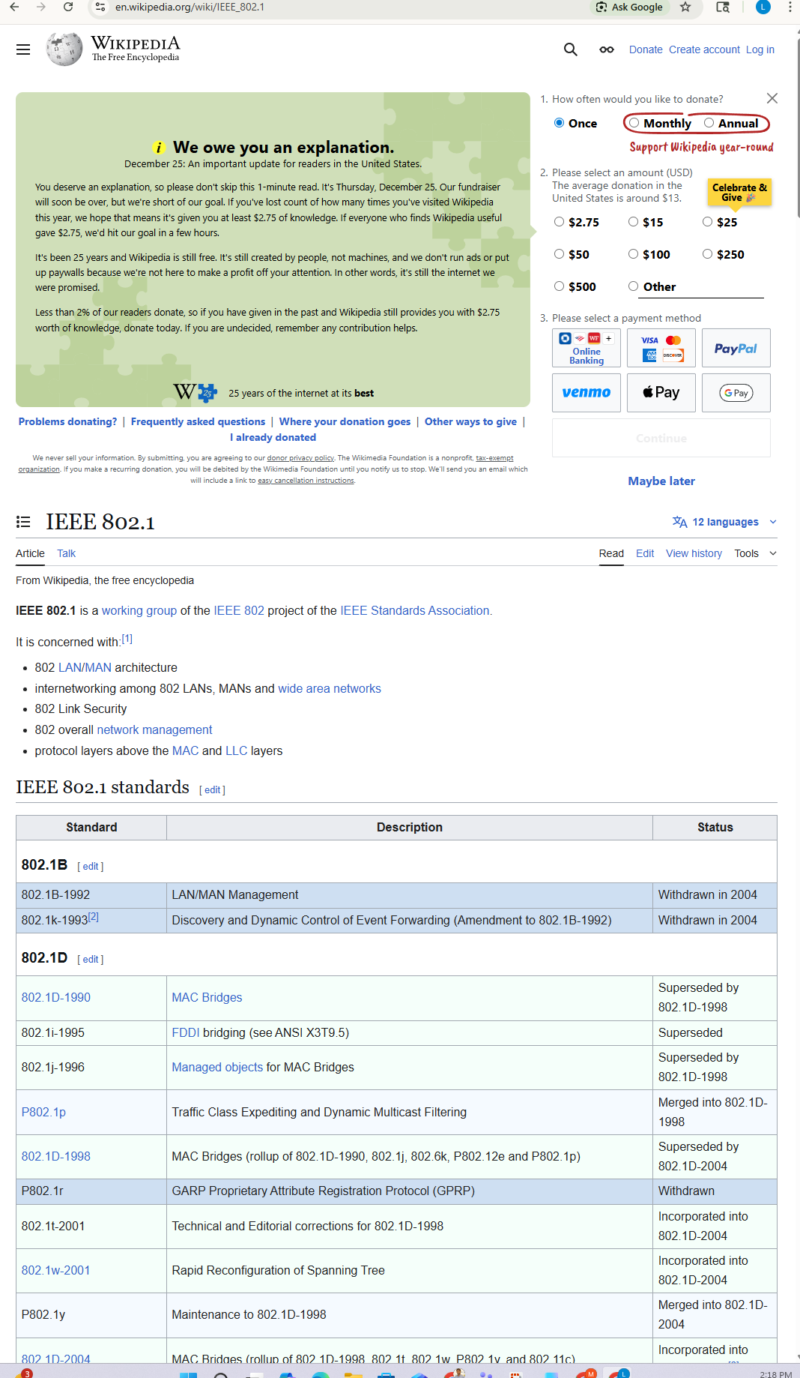
The page loaded successfully and showed information about the IEEE 802.11 family of wireless networking standards used for Wi-Fi. The article includes details on different 802.11 standards, frequency bands, throughput, and security features.
Step 5
I reviewed the Security section of the IEEE 802.11 Wikipedia article. It explains that early wireless security methods such as WEP were insecure and could be easily compromised. To address these weaknesses, stronger security protocols like WPA, WPA2, and WPA3 were introduced, providing improved encryption, authentication, and protection for wireless networks.
Step 6
A security professional would recommend disabling Wi-Fi Protected Setup (WPS) because it can be easily exploited using brute-force attacks on the WPS PIN. Even if the router is using strong encryption like WPA2 or WPA3, WPS can still allow an attacker to get access to the network. Turning off WPS helps make the wireless network more secure.
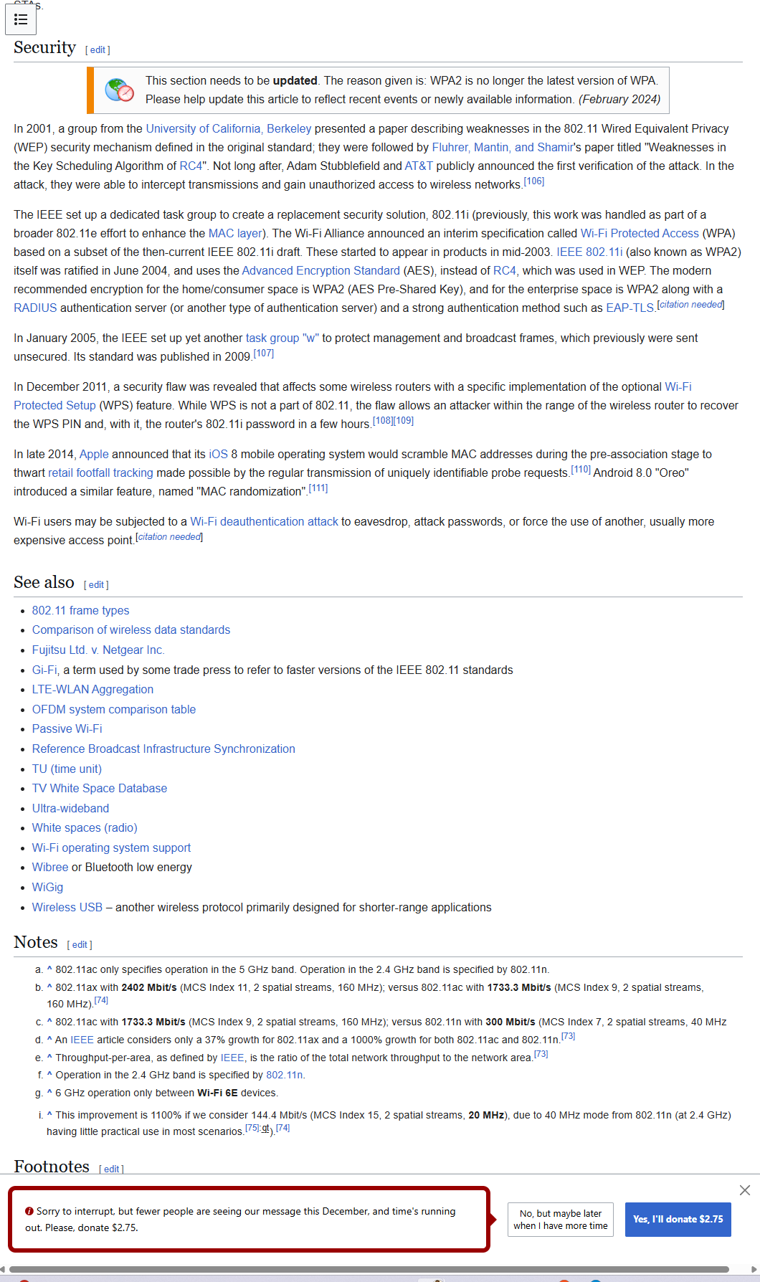

Step 7
After reviewing the required information, I closed the web browser.

Activity 11-3Discovering APs with Wifite
Step 1
If needed, I booted into Kali Linux.
Step 2
I opened a Terminal window in Kali Linux.
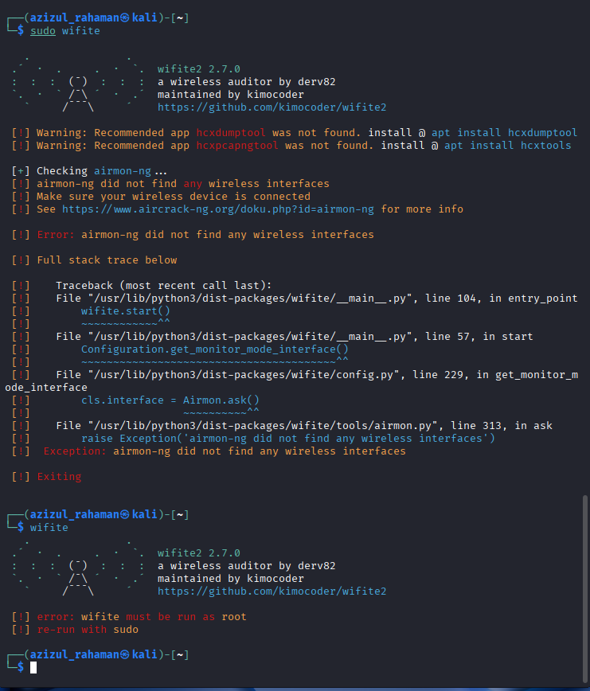
step 3:
When the SSIDs appeared on the screen, I looked at the CH (channel) column to see which channel each access point was using. I noticed that many access points were using channel 6 or channel 2, which can cause congestion. If this was found during a security test, I would suggest changing some access points to different channels to reduce interference.
Step 4:
I pressed Ctrl + C twice to exit Wifite and then closed any open windows.

